TITLE (AN, 18, CENTER, UPPERCASE)

Author (AN, 14, Bold, Centre, Capitalize Each Word) ¹

¹Author details (AN, 12,)

Accepted date:
Published date:

To cite this document:

__________________________________________________________________________________________

Abstract: (AN, 12, single spacing).

Keywords: (AN, 12, italic, single spacing)

INTRODUCTION (AN, 12, bold, UPPERCASE, align left)

Malaysia provides multiple programs to assist …… (AN, 12, single spacing, align left)

LITERATURE REVIEW (AN, 12, bold, align left)

Concepts of Entrepreneurship (AN, 12, bold, Capitalize Each Word, align left)

Entrepreneurs Motivation (AN, 12, bold, italic, Capitalize Each Word, align left)

According Ali (2018)….……. (AN, 12, single spacing, align left)

Table 1: Example (AN, 10, single spacing, bold, centre)
Example | Example | Example
Example | Example | Example
Example | Example | Example

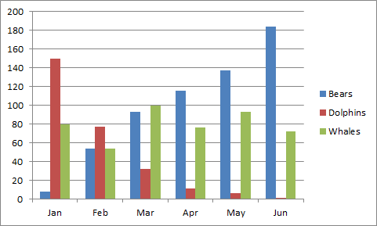
Figure 1: Example (AN, 10, single spacing, bold, centre)

References (APA Sixth Edition) – 10 references (Minimum)

